How to make a pine cone spider

Materials
- 1 pine cone
- 4 pipe cleaners
- 2 googly eyes
- Glue dots
How to make
- Fold each pipe cleaner in half.
- To make the legs you will need to wrap one pipe cleaner around the cone at a time and twist to secure until you have 8 legs.
- Bend the bottom of the pipe cleaners to make feet that will help your spider stand up.
- Glue on 2 googly eyes
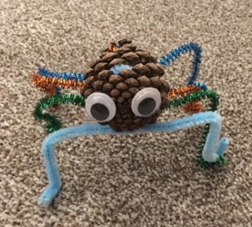
Your pine cone spider is complete

