How to make a fairy wand
Materials
- Stick
- Masking tape
- Pipe cleaner
- Glue or glue dots
Optional
- Feathers
- Stars
- Ribbon
- Pom poms
How to make
1. Choose a stick
2. Wrap each end in masking tape to make safe
3. Fasten the pipe cleaner to the top end of the stick and secure with masking tape.
4. Wrap the pipe cleaner around the stick in a spiral and secure at the bottom with masking tape.
5. Choose two leaves to fasten to one end
6. Add a feather using glue, or a glue dot to secure.It can be varied by adding a star, ribbons or pom poms
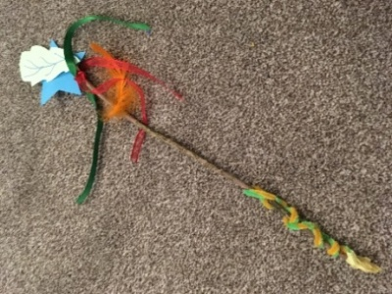
Your wand is complete.

