How to make a stick insect, grasshopper or cricket
Materials
- Stick
- 3 pipe cleaners
- 2 googly eyes or paper eyes
Optional
- Paper or fabric for wings
How to make
- Choose a stick.
- Take each pipe cleaner in turn and wrap it around your chosen stick, cross over and twist each pipe cleaner to secure.
- Fold the end of each pipe cleaner to make feet and help your insect stand up.
- Glue on your googly eyes.

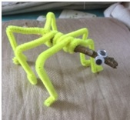
Optional
If you want to make a cricket or grasshopper draw two paper wings and fasten to your insects back.

